

**integrator.io Training**

**Session 1: Overview - Exercises**

## **Objective**

In this exercise we will be setting up a flow to pull order information from a simple REST API that would represent a webstore, and sending the information to a Slack channel to notify the team of the order information.

Slack WS :

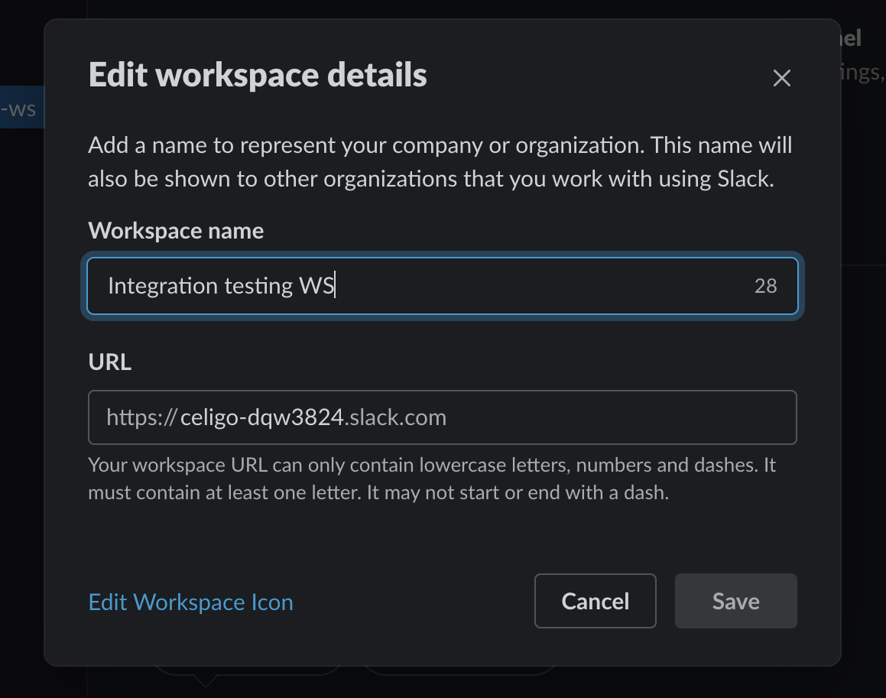

## 

## 

## **USED :**

For source flow :

1. REST API.
2. Base URI: [**This**](https://3jno0syp47.execute-api.us-west-2.amazonaws.com)
3. Auth Type : Custom
4. Media Type : **JSON**

For Export :

1. HTTP Method: **GET**
2. Relative URI: **/test/orders**
3. Export Type: **All**

For Import :

1. Slack.
2. Auth Type : OAuth 2.0
3. HTTP Method: **GET**
4. Relative URI: **/test/orders**
5. Export Type: **All**

